NetId: yz2455

Name: Yue Zhang

Lab section: Monday

Submission date: September 14, 2019

1. Cornell academic integrity quiz:

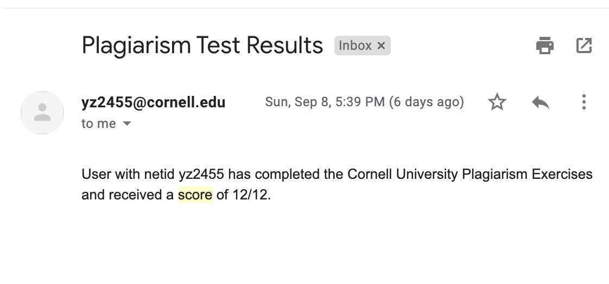

1. Already set up SD card and backup it on my laptop.
2. Login to ece5725-f19 server:

ssh yz2455@132.236.79.175



Display my user id:



Display the current directory:



Display current date and time:



Creat a “test” directory and list file in this directory:



Change the permission of home directory:



Change my default password:



1. Creat HW1.txt in test directory:

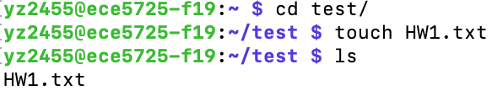

Content of HW1.txt:



Permissions:



1. What were two key events that led to the proliferation of early Unix and paved way for the eventual development of Linux?

The first key event is that Ken Thompson and Dennis Ritchie used C instead of B language to rewrite Unix.

The second key event is that Richard Stallman founded GNU(GNU’s Not Unix) operating system, which is Unix-like but differs from Unix by being free software and containing no Unix code. It is free software that enables users to share and modify their system.

1. 777:

The first 7 means 1 (User can read) 1 (User can write) 1 (User can execute), binary 111 equals decimal 7.

The second 7 means 1 (Group can read) 1 (Group can write) 1 (Group can execute).

The third 7 means 1 (Others can read) 1 (Others can write) 1(Others can execute).

Because others cannot only read and execute your files, but also they can write and change your files, which is really dangerous.

644:

The first 6 means 1(User can read) 1(User can write) 0(User cannot execute).

The second 4 means 1(Group can read) 0(Group cannot write) 0(Group cannot execute).

The third 4 means 1(Others can read) 0(Others cannot write) 0(Others cannot execute).

This permission allows user to read and write, allow Group to read, and allow others to read.

700:

The first 7 means 1 (User can read) 1 (User can write) 1 (User can execute).

The second 0 means 0 (Group cannot read) 0 (Group cannot write) 0 (Group cannot execute).

The third 0 means 0 (Others cannot read) 0 (Others cannot write) 0 (Others cannot execute).

It allows user to read, write and execute, doesn’t allow Group and Others to do anything.

1. Output of df command:



According to the format, the size settings for /home entry is 960378896 1k-blocks, which is 916G.

Human readable format:



1. Search for the processes my own:



Total number of running processes:



1. Advantages of Raspberry Pi over laptop:
2. It is much cheaper and more convenient to bring with you compared with laptops.
3. GPIO on Raspberry Pi allows users to connect it with sensors and external components and interact with them programmatically using a language such as python.

Disadvantages of Raspberry Pi versus laptop:

1. Raspberry Pi is more fragile than laptop, if we connect pins by fault, we will damage the board.
2. Raspberry Pi is not as fast as CPU processing, and it’s memory is limited compared with laptops.
3. Top command is used to show dynamic real-time processes of the system.

Htop allows users to interactively monitor the system’s vital resources or server’s processes in the real time.

Differences:

1. Using htop you can scroll the list vertically and horizontally to see all processes and complete command lines.
2. Htop starts faster than top
3. In htop you don’t need to kill a process by typing the process number

Htop is preferable to use, because of the differences above, such as in htop we don’t need to kill a process by typing the process number, and we can scroll the list vertically and horizontally to see all processes.